Photograph Specification
Many of the requirements for document processing need photograph.
For the reasons of uniformity and simplicity when making the photograph, the specifications required follow the specification of the photograph for the Canadian passport format. This means, you can simply ask the photo studio for Canadian Passport photograph.
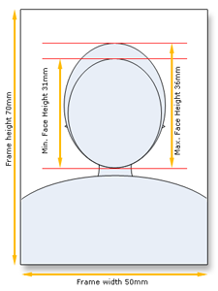

General Requirements
- The photograph must be taken within the last 6 months.
- The size of the photograph is the same as the official size of the Canadian passport photograph.
- A photograph taken in a photo booth will not be accepted.
The photograph must follows these specifications:
- All the photograph used must be the same.
- The photograph must be originals and not taken from an existing photo.
- Photos must be taken against a plain white or light-coloured background so that the applicant’s features are clearly distinguishable against the background. There should be enough contrast between the background and the traits or clothing.
- Shadows are unacceptable. Lighting must be uniform to avoid shadows across the face or shoulders, around the ears or in the background.
- There must be no reflection or glare on the face or glasses.
- Applicant must show a neutral facial expression (no smiling, mouth closed) and look straight at the camera.
- The length of the face on the photo from chin to crown of head (natural top of head) must be between 31 mm and 36 mm.
- The photos must measure 50 mm X 70 mm in size.
- The photos must be a close-up of the head and shoulders so that the face covers approximately 25% of the photo.
- Eyes must be open and clearly visible. Glasses, including tinted prescription glasses, are acceptable as long as the eyes are clearly visible and there is no glare in the glasses. Sunglasses and red eyes are unacceptable.

